|  |
| --- |
| **Digital Logic Design**  **(EL-1005)** |
| **LABORATORY MANUAL**  **Spring-2025** |



|  |  |  |
| --- | --- | --- |
| **LAB 07**  **Binary Encoder** | | |
|  |  |  |
| ________________________________________ | __________ | ___ |
| STUDENT NAME | ROLL NO | SEC |
|  | | |
| ______________________________________ | | |
| INSTRUCTOR SIGNATURE& DATE | | |
| **MARKS AWARDED: /10** | | |
| ___________________________________________________________________ | | |
| **NATIONAL UNIVERSITY OF COMPUTER AND EMERGING SCIENCES (NUCES), KARACHI** | | |

**Lab Session 07: Binary Encoder**

**OBJECTIVES:**

* Define basics of encoding mechanism
* Explain the working principle of Octal to Binary Encoder.
* Explain the working principle of Decimal to BCD Priority Encoder.

**APPARATUS:** Logic trainer, Logic probe

**COMPONENTS: ICs 74LS148 , 74LS147**

#### THEORY:

* An encoder is a device which converts familiar numbers or characters or symbols into a coded format. It accepts the alphabetic characters and decimal numbers as inputs and produces the outputs as a coded representation of the inputs.
* It encodes the given information into a more compact form. In other words, it is a combinational circuit that performs the opposite function of a decoder.
* These are mainly used to reduce the number of bits needed to represent given information. In digital systems, encoders are used for transmitting the information. Thus, the transmission link uses fewer lines to transmit the encoded information.
* In addition, these encoders are used for encoding the data which is to be stored for later use as it facilitates fewer bits storing over the available space. Let us discuss various types of binary encoders.

A binary encoder has 2n input lines and n output lines, hence it encodes the information from 2n inputs into an n-bit code. Depending on the number of input lines, digital or binary encoders produce the output codes in the form of 2 or 3- or 4-bit codes.

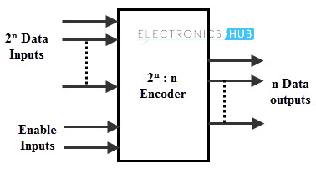

**Priority Encoder**

A priority encoder is a [circuit](https://en.wikipedia.org/wiki/Electronic_circuit) or [algorithm](https://en.wikipedia.org/wiki/Algorithm) that compresses multiple [binary](https://en.wikipedia.org/wiki/Binary_code) inputs into a smaller number of outputs. The output of a priority encoder is the binary representation of the original number starting from zero of the most significant input bits. If two or more inputs are given at the same time, the input having the highest priority will take [precedence](https://en.wiktionary.org/wiki/precedence).

### Octal to Binary (8x3) Encoder (74148)

An octal to binary encoder consists of eight input lines and three output lines. Each input line corresponds to each octal digit and three outputs generate corresponding binary code.

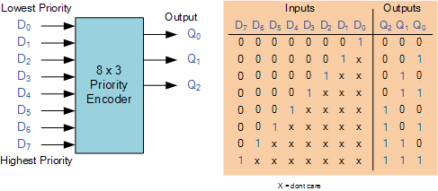

**Pin Configuration**

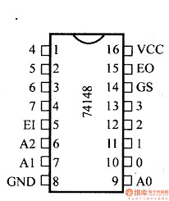 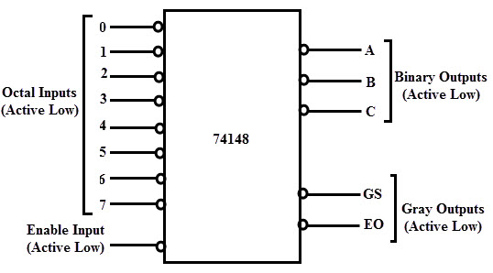

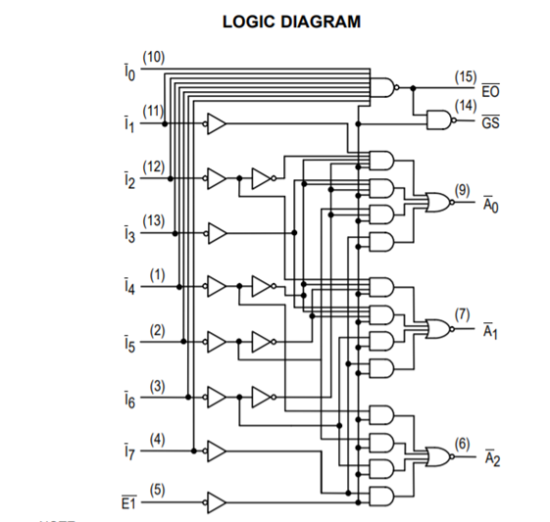

### Decimal to BCD Priority Encoder (74147)

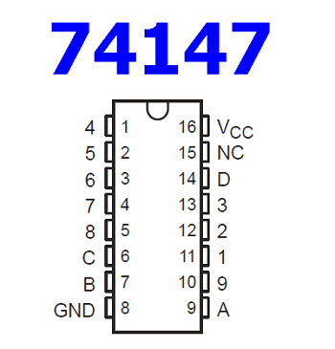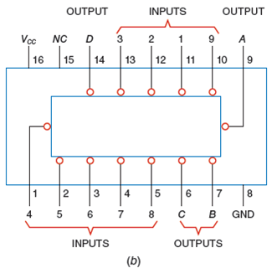

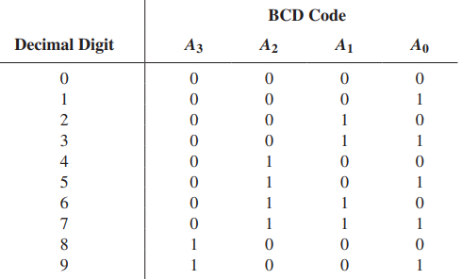

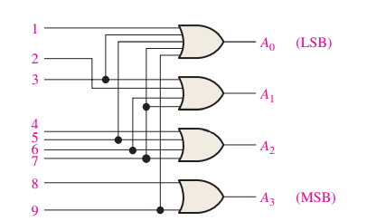

**LAB TASK**

**TASK # 01**

Design and Implement Octal to Binary Priority Encoder on Bread Board using 74148 IC.

**TASK # 02**

Design and Implement Decimal to BCD Priority Encoder on Bread Board using 74147 IC.